# **Chapter 5: Optics**

**All Lectures Uploaded on YouTube:** [**https://tinyurl.com/fkm10-physics**](https://tinyurl.com/fkm10-physics)

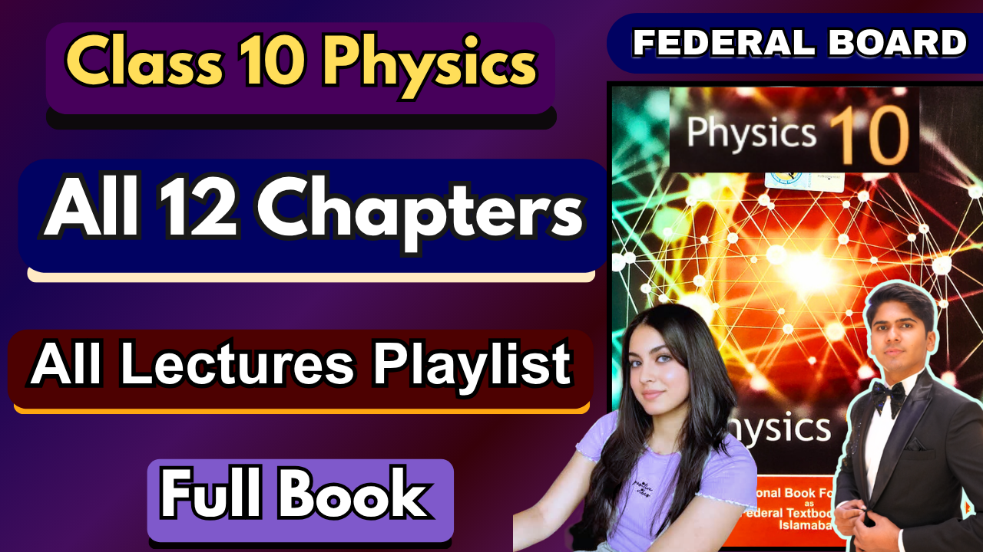

## **Optics**

Optics is the science of light and its interaction with matter. It explores the behavior of light waves, the properties of lenses and mirrors and the intricacies of human vision. But beyond its practical applications in fields like photography, microscopy and astronomy, optics holds a deeper significance.

### **14.1 Reflection of Light**

**‘When a ray of light approaches a smooth polished surface and bounces back is called reflection’.**

Reflection is the phenomenon in which light rays strike a surface and bounce back into the same medium. It occurs when light hits smooth, polished surfaces such as mirrors. Reflection is responsible for our ability to see objects. In all cases, light travels in a straight line or as a ray. The word ray comes from mathematics and it means a straight line, we would use the travelling of light in a ray diagram in this unit.

#### **14.1.1 Laws of Reflection**

1. **First Law:** The incident ray, the reflected ray, and the normal at the point of incidence all lie in the same plane.
2. **Second Law:** The angle of incidence (i), $θ_{i}$, is equal to angle of reflection (r), $θ_{r}$.  
   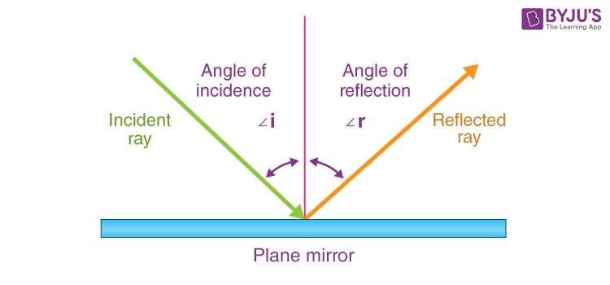

#### **A. Regular or Specular Reflection**

Occurs on smooth and polished surfaces such as plane mirrors. Reflected rays remain parallel, producing a sharp, clear image.

#### **B. Diffused Reflection**

Occurs on rough or uneven surfaces. Reflected rays scatter in multiple directions, producing no clear image. However, it allows us to see objects from any angle because scattered rays reach our eyes. This type of reflection allows us to see most non-shiny objects like this page of your book.

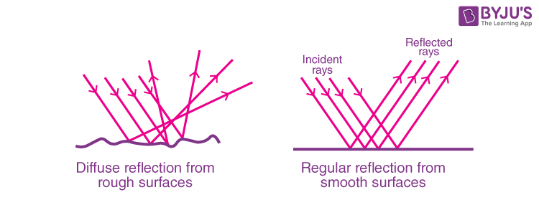

### **14.2 Refraction of Light**

**‘The changing of a light ray's direction when it passes through variations in matter is called diffraction’.**

Refraction is the bending of light when it passes from one medium to another due to change in speed. Example: A pencil partly immersed in water appears bent. Refraction is responsible for a tremendous range of optical phenomena from the action of lenses to voice transmission through optical fibers.

#### **14.2.1 Speed of Light in Material Media**

Although the speed of light in vacuum '**c**' is constant such that it is accepted as a universal constant with a fixed value:

$c=3×{10}^{8} m/s$

The speed of light through matter is less than that of in vacuum, because light interacts with atoms and molecules of the medium which hinders the speed of light that is why the speed of light depends upon the type of material.

* In **vacuum**, speed of light = *3 × 10⁸ m/s*.
* In **denser media** (glass, water), light slows down due to interaction with particles.

#### **14.2.2 Refractive Index**

**‘The measure of bending of a light ray when passing from one Glycerin 1.473 medium to another is called a refractive index such that one medium is vacuum’.**

| **Refractive Indices of Substances** | |
| --- | --- |
| **Substance** | **Refractive Index** |
| Air | 1.000293 |
| Water | 1.333 |
| Glass (crown) | 1.52 |
| Diamond | 2.419 |
| Benzene | 1.501 |
| Ice | 1.309 |

It can also be defined as the ratio of the velocity of a light ray in an empty space to. the velocity of light in a substance.

The refractive index (n) of a medium is:

$n=\frac{c}{v}$

Where:

* c = speed of light in vacuum
* v = speed of light in the medium

**It is dimensionless (no units).**

**14.2.3 Laws of Refraction (Snell’s Law)**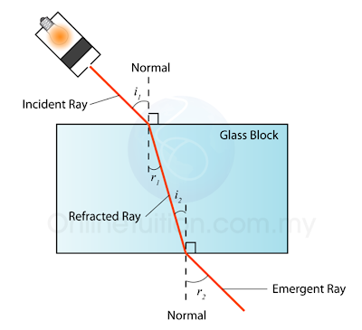

**The ray perpendicular line to the boundary of the two media is known as “normal”, the light ray coming from the first medium is known as “incident ray” and the angle it makes with the normal is called “angle of incidence” while the ray entering into the other medium is called “refracted ray” and the angle it makes with the normal is called “angle of refraction”.**

The laws of refraction are also known as Snell's law, after the name of a Dutch scientist (1591-1626) but were first given by a Muslim scientist Ibn-e-Sahl in 984 in his book “On burning mirrors and lenses”.

* **Law 1:** The incident ray, refracted ray, and normal at the interface lie in the same plane.
* **Law 2 (Snell’s Law):** The second law is about the relationship between the angles and the indices of refraction of the two media. It can be mathematically given as:

$n_{1}{sinθ}_{i}=n_{2}{sinθ}_{r}$

Where:

* $n_{1} , n_{2}$ ​ = refractive indices of media
* $θ_{i} , θ_{r}$ = angle of incidence and refraction

The same relation can also be written as:

$\frac{n_{1}}{n_{2}}=\frac{θ_{r}}{θ_{i}}$

For a medium being a vacuum, n = 1.

#### **14.2.4 Experiment to Study Refraction**

**A. Aim:** To study the bending of light through a glass block (rectangular block, semi-circular block and triangular prism made of glass).

**B. Equipment:** Laser light, protractor, sheet of paper, pencil, ruler and perspex blocks (rectangular, semicircular and prism).

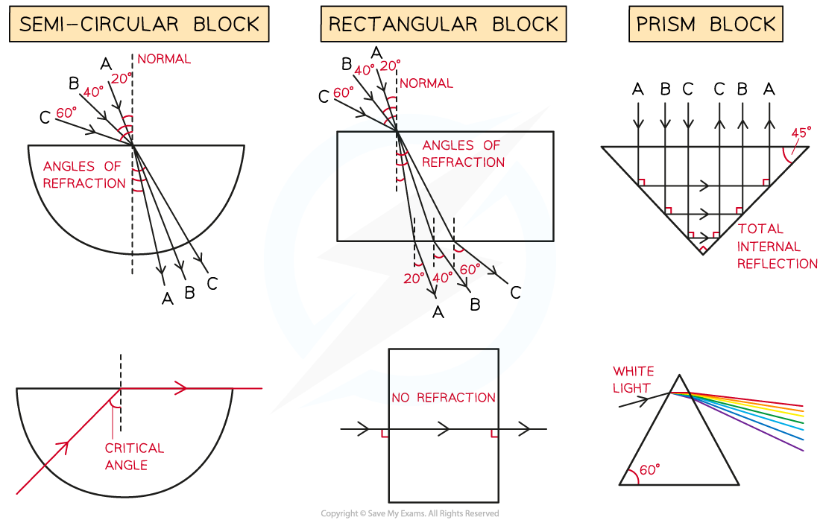

**C. Method:**

* Place the block on paper. Draw incident ray and normal.
* Insert pins along the incident ray.
* Trace emergent ray and measure i and r.
* Replace the block again and repeat the above experiment for some different angles like for 20°, 40° and 60° etc. for a semi-circular block too.
* Now take another paper sheet and perform the same experiment for the semi-circular block with three different angles and finally for a glass prism.

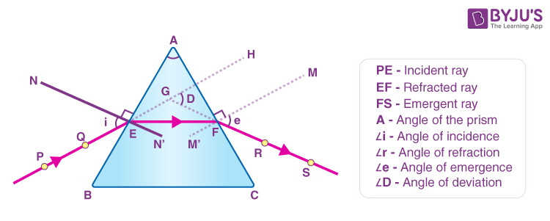

**D. Result:** Consider the light paths for different shaped blocks.

* The final diagram for each shape will include multiple light ray paths for the different angles of incidents (i) at which the light strikes the blocks.
* Label these paths for the first two blocks as A, B and C to make the paths clear.
* Incident and refracted angles are always measured from the normal.

In all the cases you would observe that:

* The light entering the block bends towards the normal line hence: (i>r).
* For light rays exiting the Perspex blocks all the light rays refract away from the normal line hence: (i<r).
* For light rays entering along the normal the light ray does not refract i.e. it passes straight through the block and hence: (i=r).

### **14.3 Total Internal Reflection (TIR)**

**“Total internal reflection is the phenomenon of reflection of light back to the same medium when passing from denser medium to rarer medium in such a way that angle of incidence is greater than its critical angle.”**

TIR occurs when light travels from a **denser medium to a rarer medium** at an angle greater than the **critical angle**, causing light to reflect back completely inside the medium.

**Critical angle ($θ_{c}$) can be defined as “The angle of incidence for which the angle of refraction is 90 degrees is called the critical angle.”**

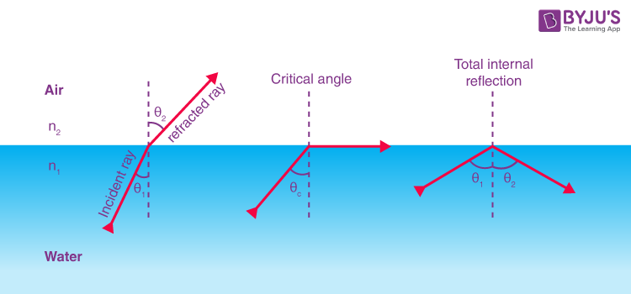

When the angle of incidence of the light ray becomes greater than the critical angle the refracted light ray also reflects back into the same medium from the boundary of two media. At this stage there is no more refraction of light and is known as the total internal reflection of light.

#### **14.3.1 Derivation from Snell’s Law**

To derive a relation for the total internal reflection we use Snell's law

$n_{1}{sinθ}_{i}=n_{2}{sinθ}_{r}$

As for total internal reflection the refracted angle becomes 90° as shown in figure, hence the above equation gets the form:

$n_{1}{sinθ}_{i}=n_{2}$**as $sin90=1$**

The sine of critical angle for the given combination of materials is:

$sinθ_{c}=\frac{n_{2}}{n_{1}}$

As we know that the trigonometric ratio of sine can have values maximum up to 1, for this it is necessary that the refractive index of first medium (from which light ray is incident) should be greater than the refractive index of ‘the second medium (in which light ray is entering) i.e. total internal reflection can only be happened if light ray travels from denser medium into the lighter medium.

#### **14.3.2 Experiment for TIR**

**A. Aim:** To observe TIR in a glass prism.  
 **B. Equipment:** Laser light, protractor, sheet of paper, pencil, ruler and perspex block.   
 **C. Method:** Shine light at different angles on the prism face. Beyond the critical angle, light reflects completely.  
 **D. Result:** Light undergoes TIR.

* In the case when the **incidence angle was less than the critical angle** we noticed the phenomenon of refraction and light entered into the lighter medium from the semi-circular glassblock: i < c.
* For the case when the **incidence angle was equal to that of the critical angle** we noticed the refracted light made an angle of 90° with the normal and traveled on the boundary between the two media: i=c.
* For the case when the **incidence angle was greater than the critical angle** we noticed the phenomenon of total internal reflection and light bounced back to the same block in spite of going into the lighter medium from the semi-circular glass block: i > c.

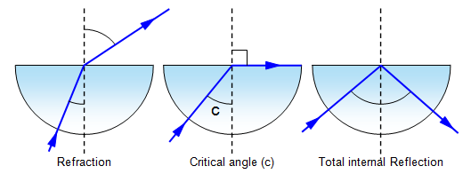

#### **14.3.3 Optical Fibers**

Optical fiber is the technology associated with data transmission using light pulses travelling along with a long fiber which is usually made of plastic or glass. The optical fibers use the application of total internal reflection of light.

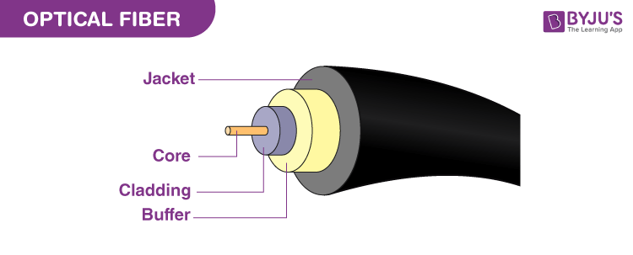

Optical fibers are glass/plastic strands transmitting light signals using TIR.

**Advantages:**

* **High Bandwidth:** Carry large data.
* **Faster Speed:** Light signals travel at near light-speed.
* **Resistance:** Immune to electromagnetic interference.
* **Long Distance:** Minimal signal loss.
* **Low Power:** Require less energy.

Optical fiber consists of two concentric tubes of glass or plastic such that the inner tube called the “core” has higher refractive index (having larger density) as compared to the outer tube called the “cladding” with low refractive index (having smaller T core density). The whole setup is covered for protection by some material called a “jacket”. The light enters into the core at an angle greater than the critical angle of the core material, moves within the core by successive total internal reflections.

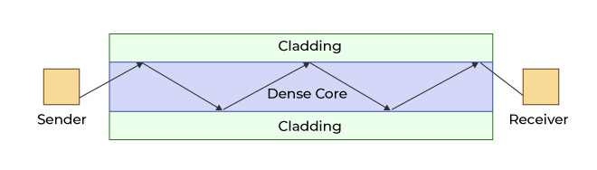

### 

### 

### **14.4 Thin Lenses**

**‘The transparent objects that refract light in specific ways to form images are called the lenses.’**

A lens is a transparent optical device with curved surfaces that refracts light to form images. Lenses are mainly of two types: **converging (convex)** and **diverging (concave)**.

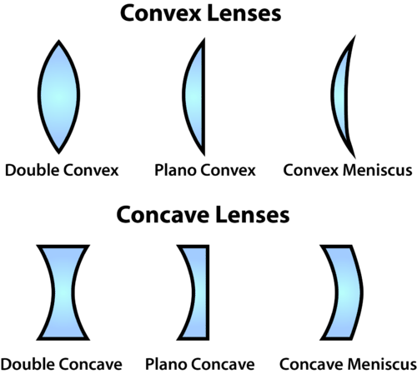

#### **Terms Associated with Lenses**

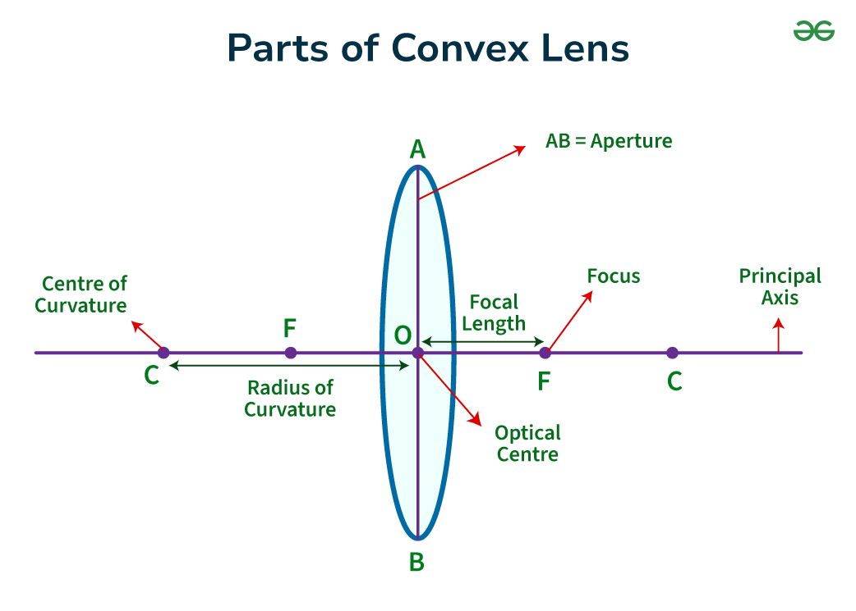

* **Focal Length (f):** Distance between the optical centre and the principal focus.
* **Principal Axis:** The straight line joining the centres of curvature of both surfaces of a lens.
* **Principal Focus (F):** Point where parallel rays converge (convex lens) or appear to diverge from (concave lens).
* **Optical Centre (O):** Midpoint inside the lens through which light passes undeviated.
* **Centre of Curvature (C):** The centre of the sphere from which the lens surface is a part.

#### **14.4.1 Action of Lenses on Parallel Rays**

**1) Converging (Convex) Lens:** Convergence lens is thicker at its center and thinner at the edges. When a parallel beam of light passes through a thin converging lens (convex lens) the lens refracts the light rays and converges them to a point known as focal point on the other side of the lens.

* **Refraction and Convergence:** Rays parallel to the principal axis bend inward and meet at the principal focus.The curvature and the refractive index of the lens material cause this bending.
* **Formation of Image:** Forms real, inverted, and magnified images depending on object position.

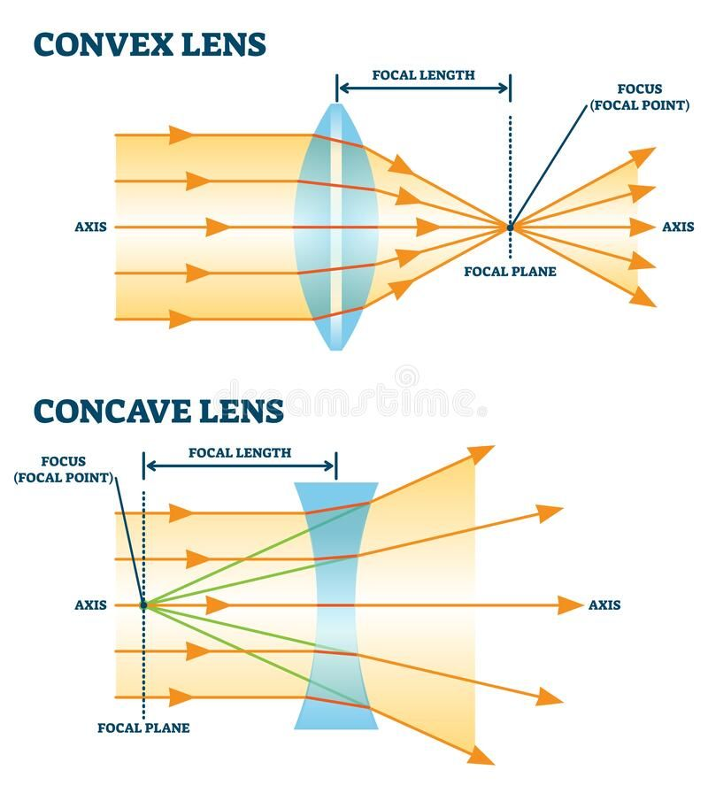

**2) Diverging (Concave) Lens:** Divergence lens is thinner at its center and thicker at the edges. When a parallel beam of light passes through a thin diverging lens (concave lens) the lens refracts the light rays and diverges them as if they are coming from a point known as the focal point on the same side of the lens from which the light is coming.

* **Refraction and Divergence:** Rays parallel to the axis diverge as if they originate from the principal focus. The light rays diverge as if they are coming from a point known as the focal point on the same side of the lens from which the light is coming.
* **Virtual Focal Point:** Appears behind the lens.
* **Formation of Image:** Always virtual, upright, and diminished.

#### **14.4.2 Ray Diagrams of Convex Lenses**

**A. Object at Infinity:** Image forms at focus, real, inverted, highly diminished.  
 **B. Object Beyond 2F:** Image between F and 2F, real, inverted, diminished.  
 **C. Object at 2F:** Image at 2F, real, inverted, same size.  
 **D. Object Between F and 2F:** Image beyond 2F, real, inverted, magnified.  
 **E. Object at F:** Image at infinity, real, inverted.  
 **F. Object Inside F:** Image on same side, virtual, upright, magnified.

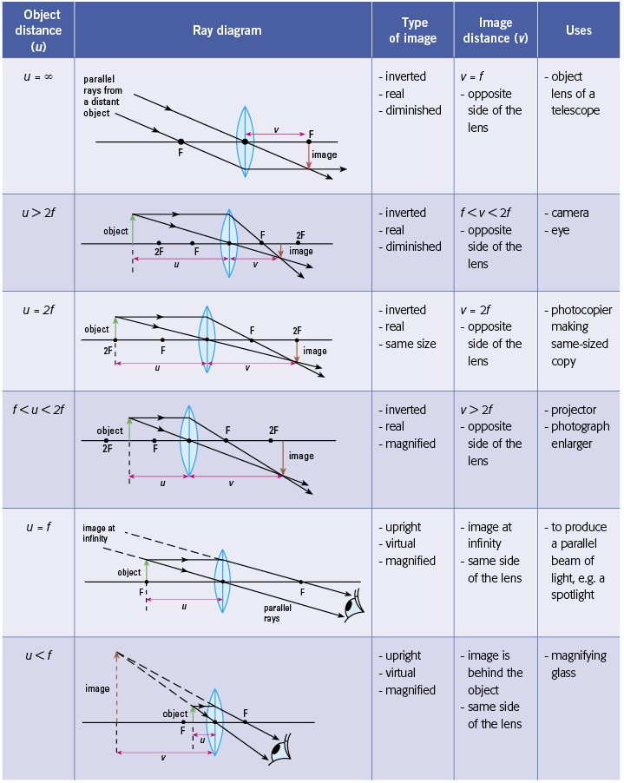

#### **14.4.3 Linear Magnification**

**‘The ratio of height (or length) of an image to the height (or length) of an object is called the linear magnification.’**

Magnification (M) is the ratio of image height to object height:

$M=\frac{I}{O}$

Where:

* I​ = image height
* O = object height

**Table: Linear Magnification**

| **Position of Object** | **Nature of Image** | **Magnification** |
| --- | --- | --- |
| At infinity | Real, diminished | M < 1 |
| At 2F | Real, same size | M = 1 |
| Between F and 2F | Real, magnified | M > 1 |
| Inside F | Virtual, magnified | M > 1 |

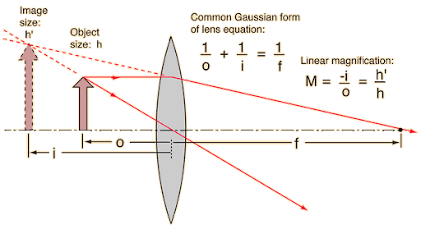

#### **14.4.4 Difference Between Real and Virtual Images**

| **Difference Between Real and Virtual Images** | |
| --- | --- |
| **Real Image** | **Virtual Image** |
| Formed by actual convergence of rays | Formed by apparent divergence of rays |
| Can be projected on a screen | Cannot be projected on a screen |
| Formed only by convex lenses | Concave, Convex, and also plane mirrors |
| Example is the image on our TV screen | Example is our reflection in mirror |
| Usually inverted | Always upright |

### **14.5 Applications of Lenses**

Lenses are fundamental optical elements that play an important role in a wide range of scientific, engineering, medical and everyday life applications from the simple magnifying glass to complex systems. They are used in consumer optics like eyeglasses, camera and binoculars, microscope optics like scientific and medical research.

#### **14.5.1 Magnifying Glass**

A convex lens is used to magnify objects. As we know that when an object is placed near the lens such that the object’s distance from the lens is less than the distance of focal point of the lens, it produces an enlarged, erect and virtual image of the object. The eye perceives this image as being larger than the actual object.

* **Position:** Object placed between F and O.
* **Distance:** Closer than focal length.
* **Viewing:** Produces a virtual, upright, magnified image.

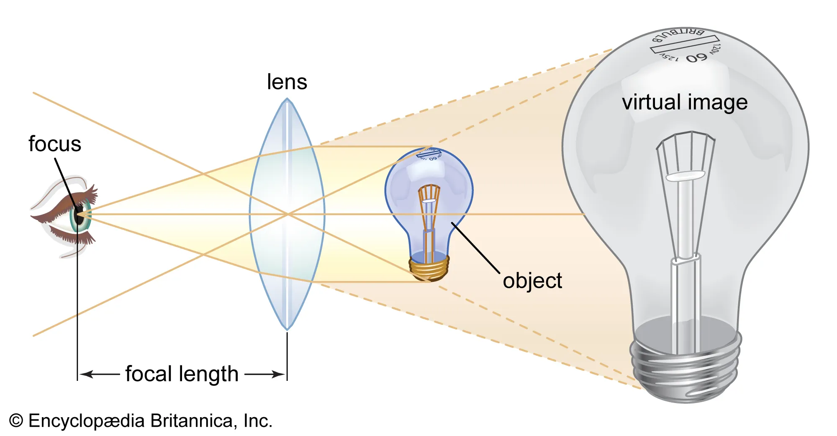

#### **14.5.2 Dispersion of Light by a Prism**

**‘The splitting of white light into seven constituent colors when passed through the prism is called the dispersion of light’.**

Dispersion is the splitting of white light into its constituent colors (spectrum) due to different refractive indices for different wavelengths.

Beyond the visible spectrum, there are wavelengths of light that the human eye cannot perceive, such as infrared and ultraviolet. These wavelengths can also be dispersed by the prism, but since they are invisible, alternative detection methods are necessary.

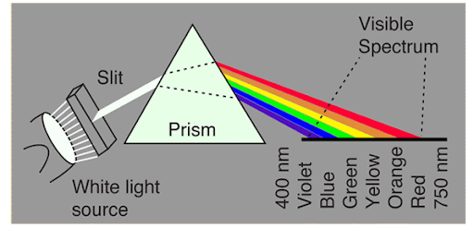

#### **14.5.3 Optical Devices Using a Single Lens**

* **Camera:** Convex lens focuses light on a photosensitive film/sensor, forming a real, inverted image.

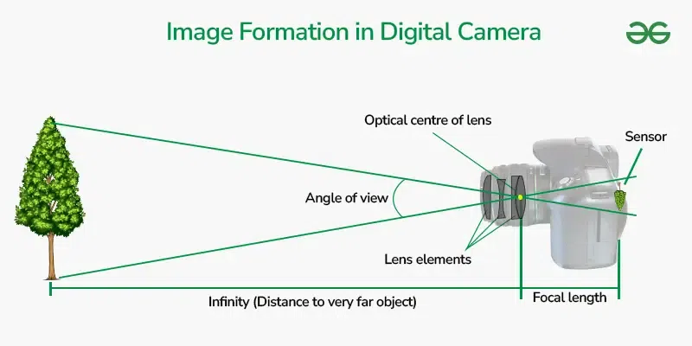

* **Projector:** Uses convex lenses to project magnified images onto a screen.

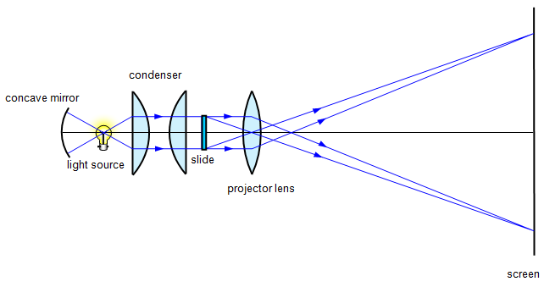

* **Photographic Enlarger:** Forms magnified images of negatives using convex lenses.  
  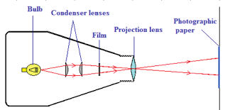

### **14.6 Visible Spectrum**

The visible spectrum consists of seven colors: Red, Orange, Yellow, Green, Blue, Indigo, Violet (ROYGBIV).

When light strikes an object, it experiences two main phenomena: some of the light is absorbed by the object (or passes through it), while the remaining light reflects off the object and enters our eyes, allowing us to see. If an object absorbs all wavelengths of light and reflects none, we perceive it as black. If it absorbs all wavelengths except for red, we see it as red.

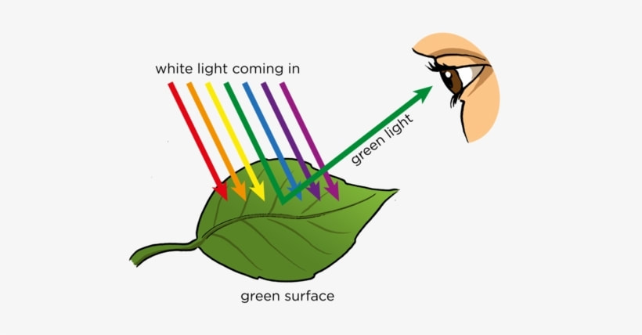

**Wavelengths and Frequencies of Colors:**

| **Color** | **Wavelength Range (nm)** | **Frequency Range (Hz)** |
| --- | --- | --- |
| Red | 620–750 nm | 4.0–4.8 × 10¹⁴ |
| Orange | 590–620 nm | 4.8–5.1 × 10¹⁴ |
| Yellow | 570–590 nm | 5.1–5.3 × 10¹⁴ |
| Green | 495–570 nm | 5.3–6.0 × 10¹⁴ |
| Blue | 450–495 nm | 6.0–6.7 × 10¹⁴ |
| Indigo | 425–450 nm | 6.7–7.0 × 10¹⁴ |
| Violet | 380–425 nm | 7.0–7.9 × 10¹⁴ |

### **14.7 Human Eye and Color Perception**

The **human eye** is a natural optical instrument that works like a camera. It captures light rays from objects, focuses them using the cornea and lens, and forms an image on the retina. The retina converts light signals into electrical signals, which are then processed by the brain to create vision.

The cornea and lens form a system that acts like a single thin lens. For clear vision a real image must be projected on the retina which lies a fixed distance from the lens. The flexible lens of the eye allows it to adjust the radius of curvature of the lens to produce an image on the retina for objects at different distances. The centre of the image falls on L the “fovea” which has the greatest density of light receptors and the sharpest in the visual field.

Processing of visual optic nerve impulses begins from the retina and ends in the brain. These optic nerves convey the signals by the eye to the brain. The cornea acts like a thin lens with an approximate focal length of 2.3 cm and the lens of the eye has an approximate focal length about 6.4 cm.

The nearest point an object can be placed so that eye can form a clear image of that object is called the “near point” of the eye and it is 25 cm from the eye.

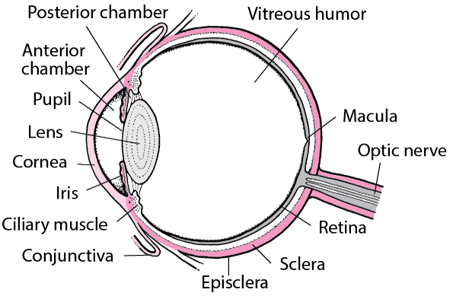

#### **14.7.1 Color Perception**

Color perception in humans depends on **photoreceptors** in the retina.

* **Rods:** Sensitive to dim light but do not detect color.
* **Cones:** Sensitive to bright light and responsible for color vision. Humans typically have three types of cones (trichromatic vision), each sensitive to red, green, or blue light.
* **Dichromatic Vision:** Some animals have fewer types of cones and thus cannot distinguish all colors as humans do.

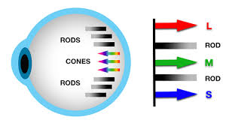

#### **14.7.2 Formation of Image on Normal Eye**

When light enters the eye, it is refracted by the cornea and lens, focusing onto the retina. A **real, inverted, and diminished image** is formed, which is then corrected by the brain to perceive the object upright.

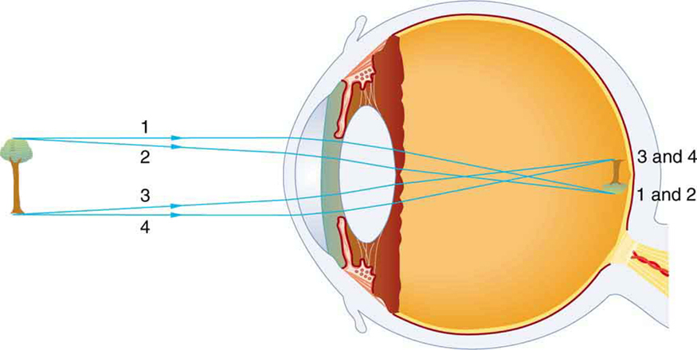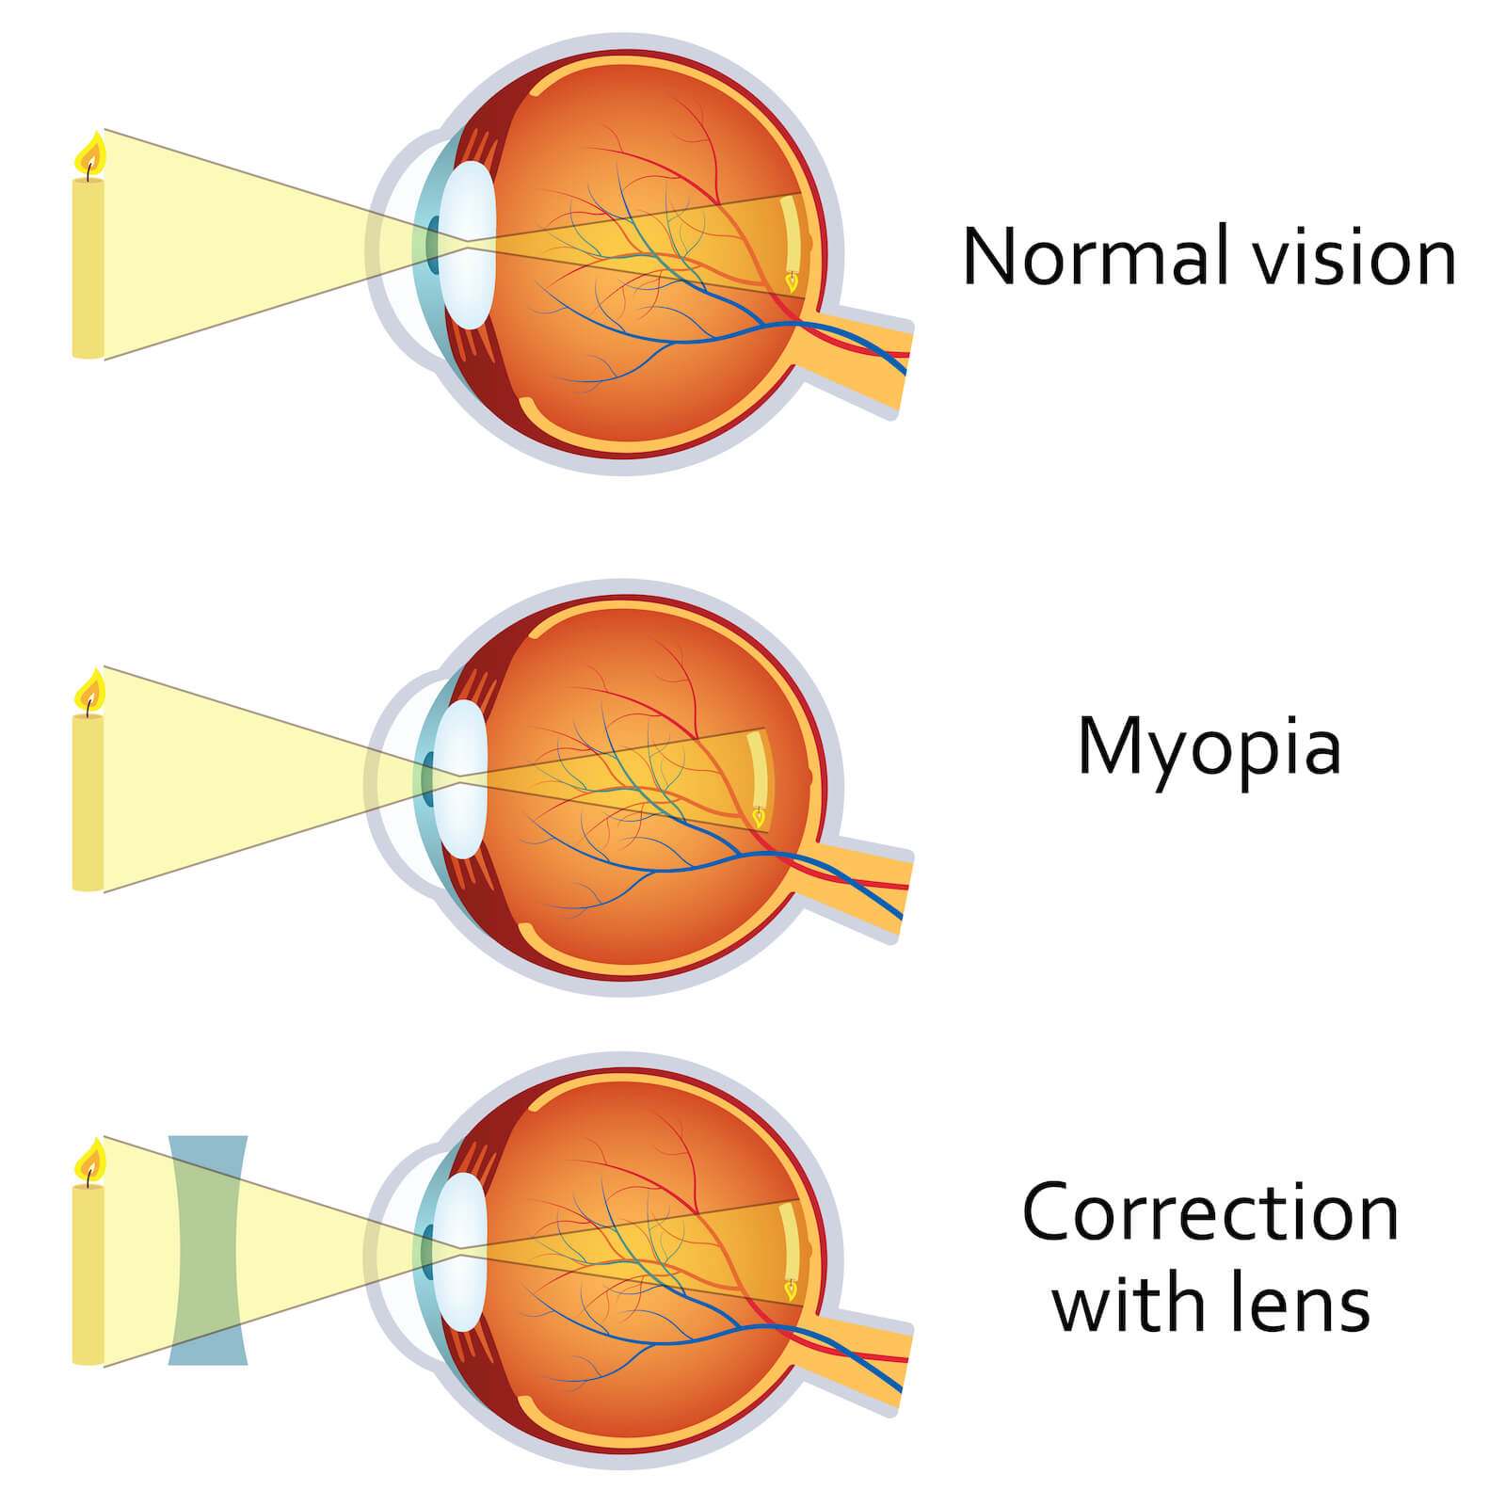

#### **14.7.3 Short-Sightedness (Myopia)**

* **Definition:** A defect where distant objects appear blurry while nearby objects are clear.
* **Cause:** The eyeball is too long, or the lens has too much converging power.
* **Correction:** A concave (diverging) lens is used to spread out light rays before entering the eye.

#### **14.7.4 Long-Sightedness (Hypermetropia)**

* **Definition:** A defect where nearby objects appear blurry while distant objects are clear. Long-sightedness or hyperopia is the condition in which a person can see distant objects clearly but near objects appear blurry to him. Hyperopia is also called hypermetropia.
* **Cause:** The eyeball is too short, or the lens has too little converging power.
* **Correction:** A convex (converging) lens is used to bring rays to focus correctly on the retina.

### **14.8 Gravitational Lensing**

**‘The phenomenon in which a massive celestial body causes a sufficient curvature of space-time for the path of light around it to be visibly bent as if by a lens is called gravitational lensing.’**

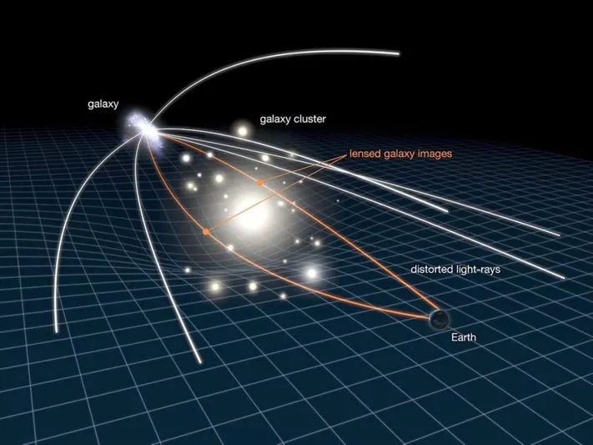

Gravitational lensing is the bending of light rays when they pass near a massive object, such as a star, planet, or galaxy. According to Einstein’s Theory of General Relativity, mass curves spacetime, and light follows this curvature, causing a lensing effect.

**Applications of Gravitational Lensing:**

* Helps astronomers detect dark matter.
* Allows viewing of distant galaxies otherwise too faint to observe.
* Produces multiple images of the same astronomical object.

### **14.9 Acoustic Lensing**

**‘The branch of physics that deals with examining and studying the sound is called acoustics.’**

Acoustic lensing is the process of focusing sound waves in a manner similar to how optical lenses focus light waves. It uses specially shaped materials or structures to bend sound waves to a focal point.

It deals with the production, transmission and effects of sound. The main application of acoustics is to make the music or speech sound as good as possible.

**Applications:**

* Used in medical imaging (ultrasound focusing).
* Applied in underwater sonar systems.
* Helpful in architectural acoustics to direct sound.

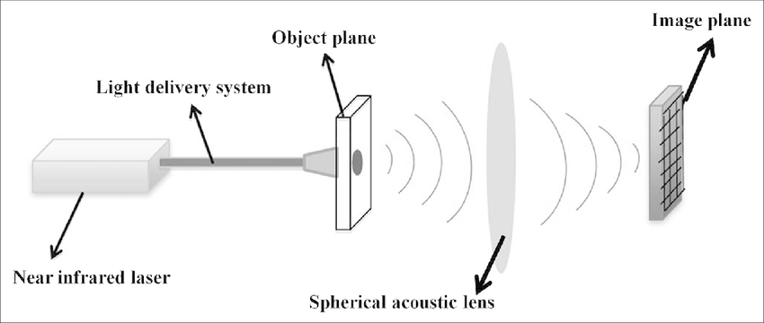

#### **14.9.1 Types of Acoustic Lenses**

1. **Slant-Plate Lens:**
   * Consists of slanted plates placed in a medium.
   * Causes sound waves to bend towards a focal point by altering their travel path.  
     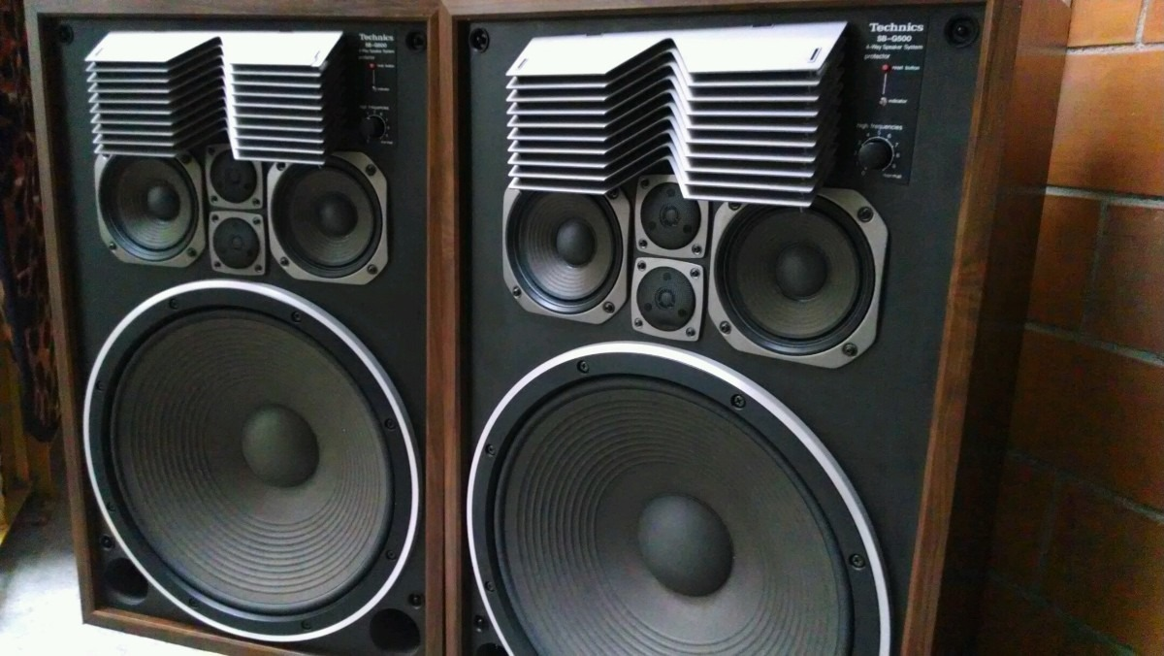
2. **Perforated-Plate Lens:**
   * Uses plates with holes to create phase shifts in the sound waves.
   * Results in convergence of sound similar to how curved glass focuses light.

#### 

#### **14.9.2 Materials and Shapes of Acoustic Lenses**

Acoustic lenses are made from materials that efficiently transmit sound, such as plastics, metals, or specialized composites. Their effectiveness depends on shape: convex, concave, or specially engineered forms that determine how sound is focused.

**A. Plastic**: Plastic materials are commonly used for making acoustic lenses because it can easily be fabricated and have good acoustic properties.

**B. Epoxy:** Epoxy is also commonly used material for making acoustic le'nses it offer good sound permeability and can be molded into specific shapes.

**C. Rubber:** Rubber is used in acoustic lenses for their flexibility and the ability to deform the lenses.

**D. Liquid:** Some acoustic lenses use liquid filled chambers to converge or diverge sound waves. Similarly acoustic lenses come in different shapes each shape serves specific purpose. They can be shaped in spherical, ellipsoidal, parabolic and gradual geometric curves as explained here:

**E. Spherical Acoustic Lenses:** These acoustic lenses have curved surfaces like a sphere, they focus or diverge the sound waves according to their curvature.

**F. Ellipsoidal Acoustic Lenses:** These are similar to spheres but a little elongated in one direction (somehow like an egg) they can focus sound waves in a specific direction.

**G. Parabolic Acoustic Lenses:** These acoustic lenses have a parabolic shape and are excellent at focusing sound waves to a single point.

**H. Gradual Geometric Acoustic Lenses:** Lenses with gradual geometric curves achieve gradient refractive index distribution allowing precise acoustic focusing.

**Characteristics:**

* Must have minimal energy loss.
* Should withstand operational environments (e.g., underwater pressure for sonar lenses).
* Designed based on wavelength of sound to achieve proper focusing.



